1. Write a python program to show how BFS & DFS work on the search tree for given state space graph.

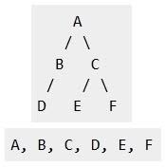

1. Explore the search space using search strategies and formulate the problem components for the 8-Queens problem using the following information: Place 8 queens on a chessboard such that none of the queen’s attack any of the others. A configuration of 8 queens on the board as shown in the figure below, but this does not represent a solution as the queen in the first column is on the same diagonal as the queen in the last column.
2. Write a Prolog program for a Planets Database with the following facts.

orbits(mercury, sun).

orbits(venus, sun).

orbits(earth, sun).

orbits(mars, sun).

orbits(moon, earth).

orbits(phobos, mars).

orbits(deimos, mars).

1. Write a python program for Forward chaining algorithm for the following problem:

The law says that it is a crime for an American to sell weapons to hostile nations. The country Nono, an enemy America, has some missiles, and all of its missiles were sold to it by Col. West, who is an American. Prove that Col. West is a criminal.

1. Write a python program to trace out how the searching process works for the given graph using bidirectional Search.

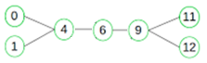

1. Write a python program for A\* search for the given tree, in which ‘A’ is the initial state and ‘E’ goal state. For each node in each stage, obtain cost estimates where g(n) is the numeral by the side of an arc and h(n) is the numeral at the node.

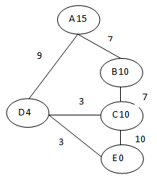

1. Write a Prolog program with FName, SName, Sex, Age and Occupation

person(frances, wilson, female,28,architect).

person(fred, jones,male,62,doctor).

person(paul, smith, male,45,plumber).

person(martin, williams, male,23,chemist).

person(mary jones, female, 24, programmer).

person(martin, johnson,male,47,solicitor).

man(A):-person(A,B,male, C, D).

1. Write a Prolog program to implement the best sequence of actions to the A monkey is in a room. Suspended from the ceiling is a bunch of bananas, beyond the monkey's reach. However, in the room there are also a chair and suck. The ceiling is just the right height so that a monkey standing on a chair could knock the bananas down with the stick. The monkey knows how to move around, carry other things around, reach for the bananas, and wave a stick in the air.
2. Write a python program to solve the Water Jug problem: you are given 2 jugs, a 4-gallon one and 3-gallon one. Neither has any measuring maker on it. There is a pump that can be used to fill the jugs with water. How can you get exactly 2 gallons of water into 4-gallon jug? Explicit assumptions: A jug can be filled from the pump, water can be poured out of a jug onto the ground, water can be poured from one jug to another and that there are no other measuring devices available.
3. Write a python program to solve the following crypt arithmetic problem using CSP.

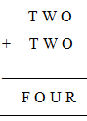

1. Write a Prolog program for the forward chaining using following facts

rainy(chennai).

rainy(coimbatore).

rainy (ooty).

cold(ooty).

1. Write a Prolog program for forward Chaining As per the law, it is a crise for at American to sell weapons to hostile nations Country A. an enemy of America, has some missiles, and all the missiles were sold to it by Robert, who is an American citizen. Prove that "Robert is criminal."
2. Write a python program to calculate the optimal solution using manhattan distance for the given 8 puzzle problem,

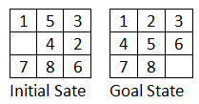

1. Write a python program to solve the given min-max tree and find the optimal path for MIN to win the game.

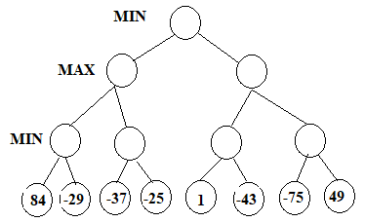

1. Write a Prolog program with FName, SName, Sex, Age and Occupation

person(frances, wilson, female,28,architect).

person(fred, jones,male,62,doctor).

person(paul, smith, male,45,plumber).

person(martin, williams, male,23,chemist).

person(mary jones, female, 24, programmer).

person(martin, johnson,male,47,solicitor).

1. Write a Prolog program to print particular bird can fly or not using following facts

Bird (cagle)

Bird (sparrow)

Bird (penguin)

Fly (penguin)-1, fail.

Fly(X):- bird(X).